**SFTP ASSIGNMENT**

**Que.1 What is SFTP and what is the SuiteApp needed to set up SFTP connection and financial Institution record in NetSuite?**

***SFTP:***

* SFTP stands for Secure File Transfer Protocol.
* It is a secure version of FTP.
* It is generally used to transfer any file from any source to destination over a secure network.
* In NetSuite it is used to transfer files from NetSuite to Bank (Financial Institution).

Click on SuiteApps after hovering over on 3 horizontal dots.

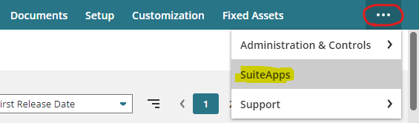

Now search for SFTP Connector and install it.

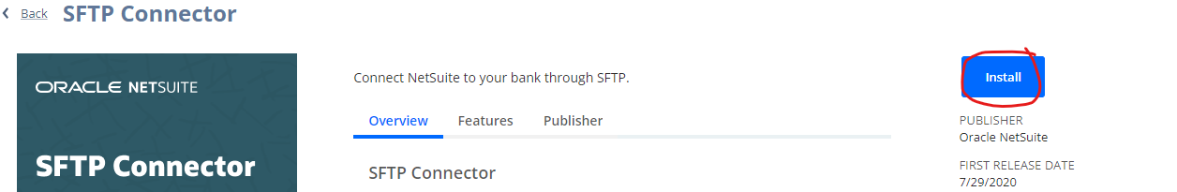

This SuiteApp establishes an SFTP connection between the NetSuite account and a remote SFTP server, enabling the transfer of payment files from NetSuite to the bank servers and also allow us to download the files from bank server.

**Que.2 What is the use of fields which are present in outbound and inbound configuration records? Explain in detail.**

**Outbound Configuration:**

Outbound Configuration in NetSuite refers to a setup used to manage the secure transmission of files or data from NetSuite to external systems or servers.

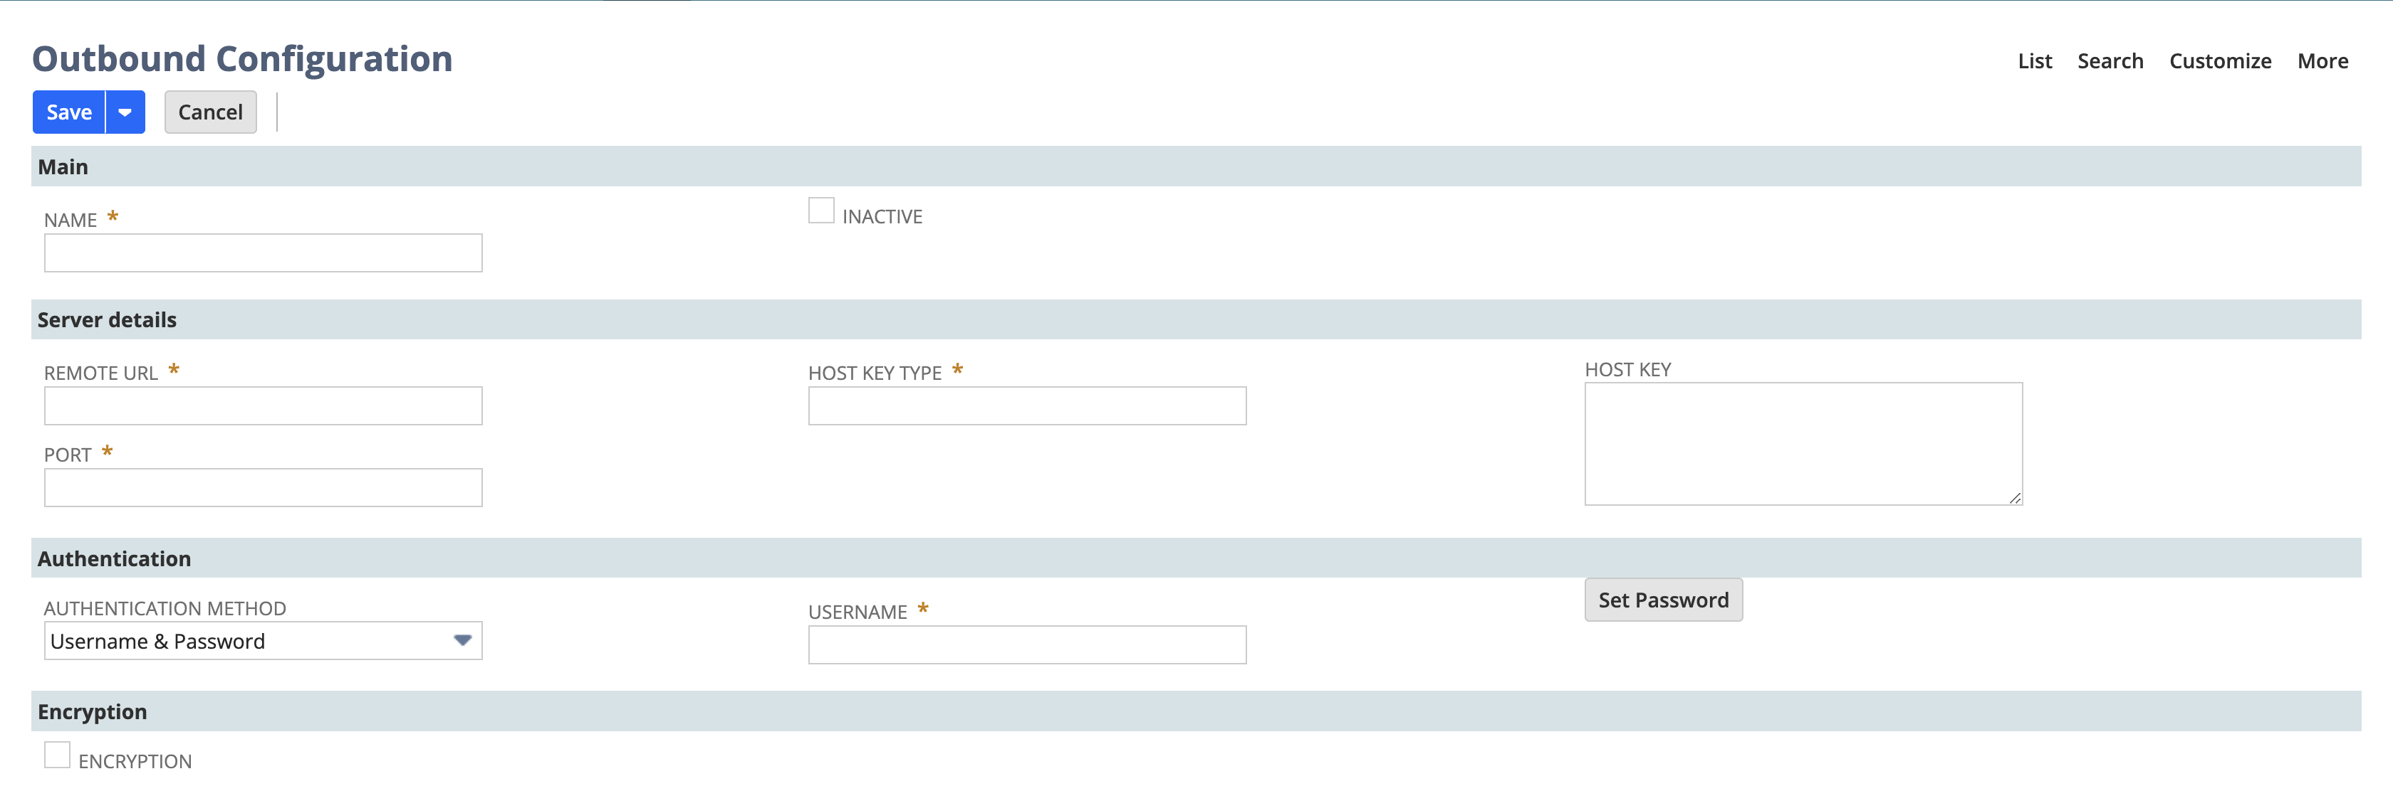

1. ***Name***: This is the name given to the outbound configuration record to help identify it. (e.g., Bank Payment Transfer).
2. ***Remote URL***: The URL of the remote server where the data or file needs to be sent. NetSuite will use this URL to connect to the external system or server (e.g., SFTP server, API endpoint).
3. ***Port***: The network port number through which the connection will be established. Different services use specific ports (e.g., port 22 for SFTP). We must specify the correct port to communicate with the external server.
4. ***Host Key Type***: Specifies the type of key used to authenticate the server (e.g., RSA, DSA). It ensures secure communication by verifying the identity of the remote server through a known host key type.
5. ***Host Key***: It stores the public key of the remote server. This is used to verify the server’s identity during the connection.
6. ***Authentication Method***: This dropdown specifies the method of authentication used to connect to the remote server. It could be:
   1. Username & Password: Basic authentication using credentials.
   2. SSH Key: Secure connection using SSH keys. SSH keys are provided by your bank.
7. ***Username***: The username used for authentication when connecting to the remote server. We must enter the username given by the bank to authenticate the SFTP connection.
8. ***Encryption***: A checkbox to enable encryption of the connection to secure the transmission of data. When enabled, the connection will use encryption protocols (e.g., SSH, SSL) to secure the data being transmitted on a secure network.

**Inbound Configuration:**

Inbound Configuration in NetSuite refers to the setup used to import or receive files or data from external systems into NetSuite.

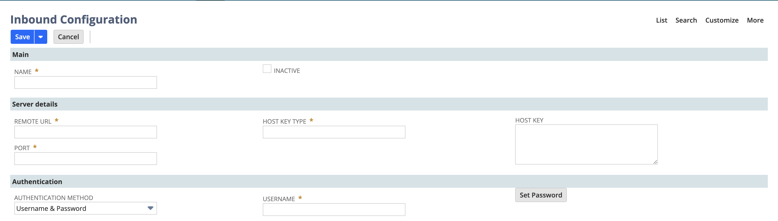

1. ***Name***: The name given to this inbound configuration. (e.g., "Bank Statement Import").
2. ***Remote URL***: The URL of the remote server from which the files or data will be imported. It is provided by the bank to connect to the bank server.
3. ***Port***: The network port number to be used for connecting to the remote server to establish the connection. Common ports include 21 (FTP) and 22 (SFTP).
4. ***Host Key Type***: Specifies the type of host key used for verifying the server’s identity during connection (e.g., RSA, DSA, ECDSA). This ensures secure communication.
5. ***Host Key***: The actual host key from the external server, used to authenticate the connection. It verifies that we are connecting to the correct server and not an imposter. The host key must be in Base64 encoding format. We can use the host key provided by the bank or we can use the ssh-keyscan -t <host key type> -p <port number> <URL>key available for the specific port.
6. ***Authentication Method***: The method used to authenticate when connecting to the remote server.
   1. Username & Password: The most common method, requiring you to enter a username and a password for access.
   2. SSH Key: An alternative method using SSH (Secure Shell) keys for more secure, password-less authentication.
7. ***Username***: The username for accessing the remote server. It is a required field for authentication.
8. ***Encryption***: A checkbox to enable encryption for the file transfer. When checked, data is transferred securely using encryption protocols (like SFTP, which encrypts files during transmission).

**Que.3 How to generate public and private key from our end? Explain.**

***Step 1*** – Download a software called **WinSCP** on our local system.

***Step 2*** – After opening it under the Tools dropdown click on Run **PuTTYgen**.

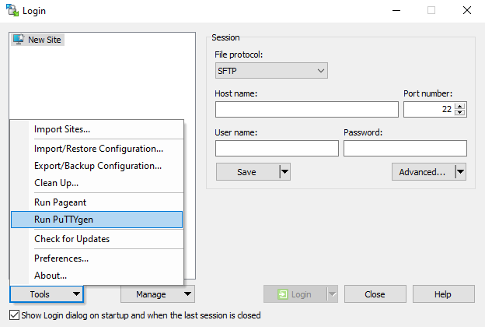

***Step 4*** – Now click on the generate key button, then it will generate a public key with extension **.pub** and a private key with extension **.ppk**

***Step 5*** – Now just save the public key and private key one by one.

***Step 6*** – Remember that while deploying the private key we must change its extension from **.ppk** to **.pem**

**Que.4 Where are the private keys located in NetSuite? Create one private key record in NetSuite.**

***Step 1*** - To create a private key, Navigate to, Setup -> Company -> Keys.

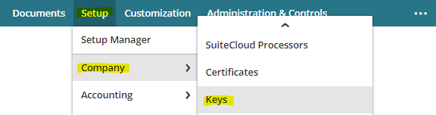

***Step 2*** - Now go to puTTYgen and convert the private key from .ppk to .pem and download it.

***Step 3*** – Now give a name, id and upload the private key and then hit Save.

***Step 4*** – Now you can see our private key created successfully.

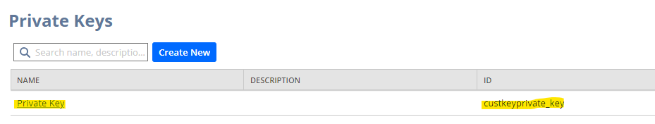

**Que.5 What are the authentication methods available for connecting to a remote server?**

There are three types of authentications. We can find it when establishing inbound or outbound connection between NetSuite server and bank. These are: Username & Password, Certificate / SSH Key, Multi-factor Authentication.

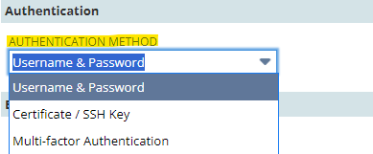

***Username & Password***:

It requires the user’s credentials such as username and password which have to be put by the user itself. After entering the username and password, the entered credentials will be matched with the stored data of the user.

***Certificate/ SSH Key:***

SSH key is known as Secured Shell. It’s a bit secure than username and password. It involves using a public-private key pair for authentication. The public key of the user is uploaded to NetSuite. When any request for authentication happens, the server checks it against the public key of the bank and then connection is made.

***Multi-factor Authentication:***

It adds an additional security layer to the authentication. It is the most secure way as it not only requires the password, but also a second factor of authentication. It may be an OTP or a verification mail that can be sent to the user’s mobile or system just like as we use multi factor authentication in our google mail.

**Que.6 What are the ways available for transmitting or importing the files in NetSuite?**

***CSV Method:***

* Go to Setup > Import/Export > Import CSV Files.
* Choose the file, select the type of record to import
* We can manually upload and import files through the CSV Import tool in NetSuite.
* This method is often used for importing transactional data (e.g., journal entries, customer records, or bank statement files).

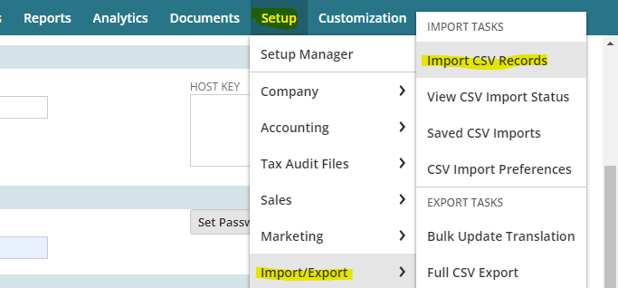

### ***File Cabinet:***

* Go to **Documents** > **Files** > **File Cabinet**.
* Upload your file and access it from the File Cabinet or use it in scripts/workflows.
* Files can be manually uploaded to NetSuite’s **File Cabinet**, and then processed within scripts, workflows, or transactions.
* If we want to store files (such as PDFs, images, or data files) in NetSuite for use in various business processes, we can use the file cabinet.
* **It can store any file type (PDFs, images, text files, data files, etc.).**

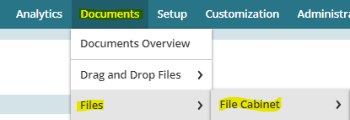

### ***SFTP:***

* We have to navigate, SFTP -> SFTP records -> Inbound or Outbound configuration to import or export data respectively.
* Files can be transferred automatically using **SFTP**, **FTP**, or via **Web Services** integration for secure, automated data exchange between NetSuite and external systems.
* It is used for automating the process of importing/exporting data (e.g., bank files, payment files) between NetSuite and a third-party system.

**Que.7 What is the use of financial Institution record and format profile record? Explain**

In NetSuite, both f**inancial institution records** and f**ormat profile records** play important roles in setting up and managing banking transactions and electric fund transfer.

### **Financial Institution Record:**

* It stores the details of the bank d financial records where a business has an account.
* This record is used to establish a connection between the NetSuite system and the actual bank for handling transactions like bank transfers, deposits, electronic payments and bank reconciliation to match the transaction of company with the bank.
* It includes data such as bank name, bank code, account numbers, public key, private key and routing numbers.
* It centralizes all necessary banking information, making it easier to manage multiple banks and automate electronic payment processes directly from NetSuite.

**Example**: If you have an account with Bank of America and want to automate payments or pull in bank statement data, you have to create a financial institution record for Bank of America.

### **Format Profile Record:**

* It defines the format in which data will be exchanged between NetSuite and the bank for specific transactions like payment files.
* It ensures that the bank data (such as payment instructions or bank statements) is formatted correctly when sent or received. As different banks have different format requirements, the format profile handles it efficiently.
* Format profile records enable seamless communication between NetSuite and the bank by ensuring that the data sent or received follows the required format and preventing errors.

**Example**: If your bank requires payment files to be in a specific ACH format, the format profile record ensures that NetSuite generates the file in the correct format before sending it to the bank.

**Que.8 Difference between Inbound Configuration and Financial Institution.**

***Inbound Configuration:***

* It defines how bank data, such as bank statements and files are imported into NetSuite from a bank.
* It helps automate the process of receiving transaction details from the bank and to process it easily.
* We have to configure the connection between NetSuite and the bank’s system, so we can directly receive the data from the bank itself.

***Financial Institution:***

* It represents the actual bank or financial entity (e.g., Bank of America, Wells Fargo).
* It allows us to link specific accounts in NetSuite to the bank for activities such as payments or bank transactions.
* We can set up multiple financial institutions if our business holds multiple accounts with multiple banks, allowing us to manage payments and reconciliations across all of them.